Forensic Evidence

Exhibit A: Blue Dress – found in the trash can behind the theater, size XL, no visible tears in fabric.
Exhibit B: Script – Pages 1 -28, torn on the binding, blood stains match the victim, fingerprints on the exterior cover include the victim, Sally McBride and Amber Graves
Exhibit C: Script – Pages 30-65, torn on the binding, matches exhibit A, no blood stains, only partial fingerprints were found on pages 30. Back cover Fingerprints Sally McBride and Johnny Wilde.

From the desk of Tinkerbell 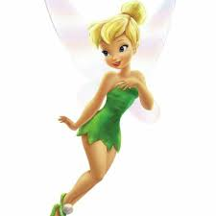

Do the right thing. Don’t leave me hanging again!

